 **Let’s keep going on our Projects!!**

Last week, we found 3-5 cool findings based on the music and movie preferences from Ms. Shapiro’s friends. We are going to keep working on that and try to make **AWESOME** visualizations!

Here is a step-by-step guide on how to make visualizations for your WOW project.

# **Here’s what to do:**

1. Break into the groups you worked on last week as determined by Mr. Baxter.
2. Get ChromeBooks for your group to work on.
3. Go to [**https://onedrive.live.com/about/en-us/**](https://onedrive.live.com/about/en-us/) and in the top right corner press the button that says “**Sign in”** and enter your email address. Press **“Next”.**
4. Login using your username and password.

*## Ask Mr. Baxter for help if you don’t remember your emails and passwords.*

## **Let’s create a PowerPoint for us to save our results in!**

1. 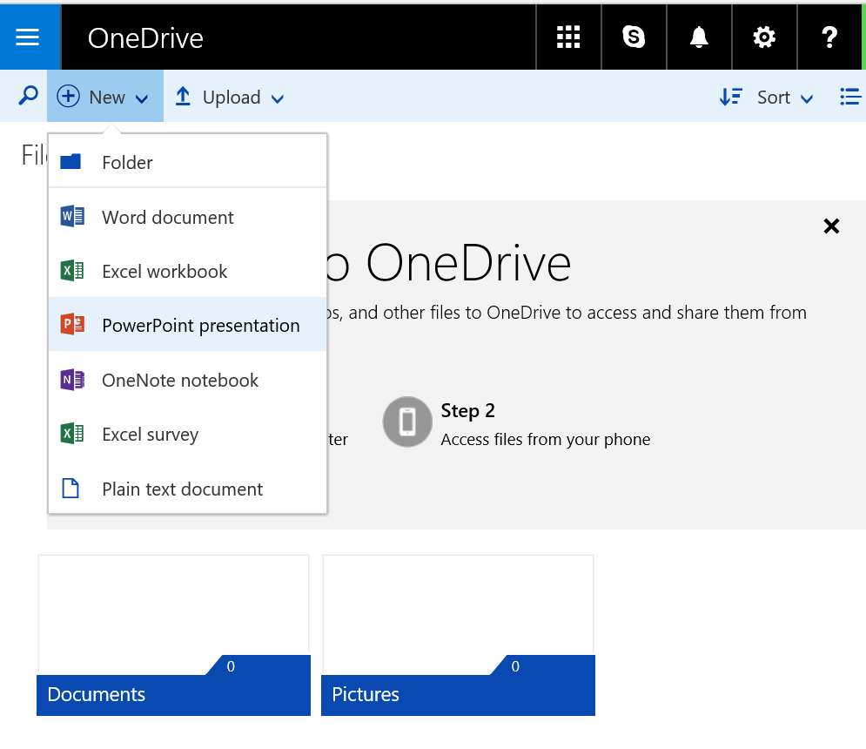After you login, press the button on the top bar that says **“New”** and click PowerPoint presentation.

### **Now we have a place to put all of our results in! We will work on our presentation itself in a later class.**

## **Let’s get back to the data:**

1. **Keep the PowerPoint window open and open a new tab in the browser.**
2. Go to [**http://aka.ms/rsadataexcel**](http://aka.ms/rsadataexcel).
3. 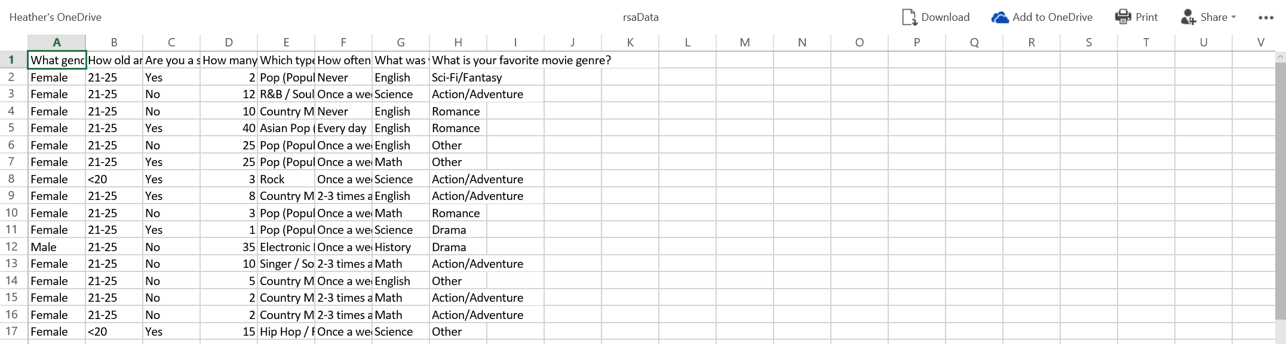In the top right corner, select the option to “**Add to OneDrive”.**



1. Press “**Save”.**

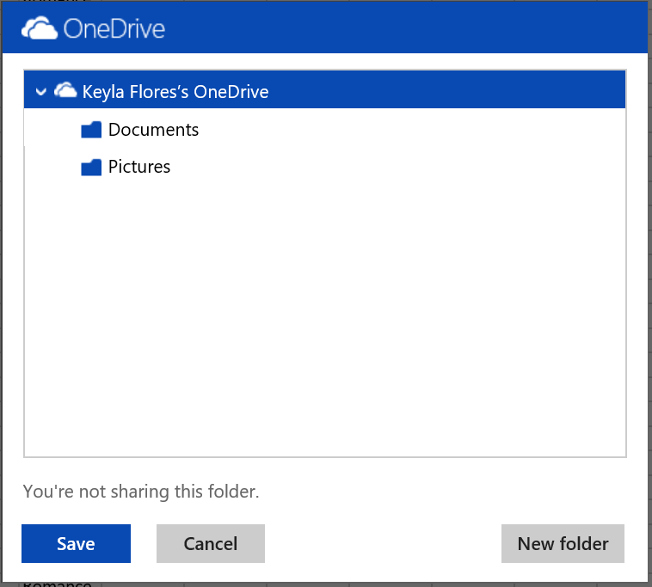



1. **The Excel file will now open in the browser and you and your team can start making visualizations!**

## **Visualization time!**

1. Select all of the data in the worksheet and press “**Ctrl” and “C” at the same time** to copy the data.

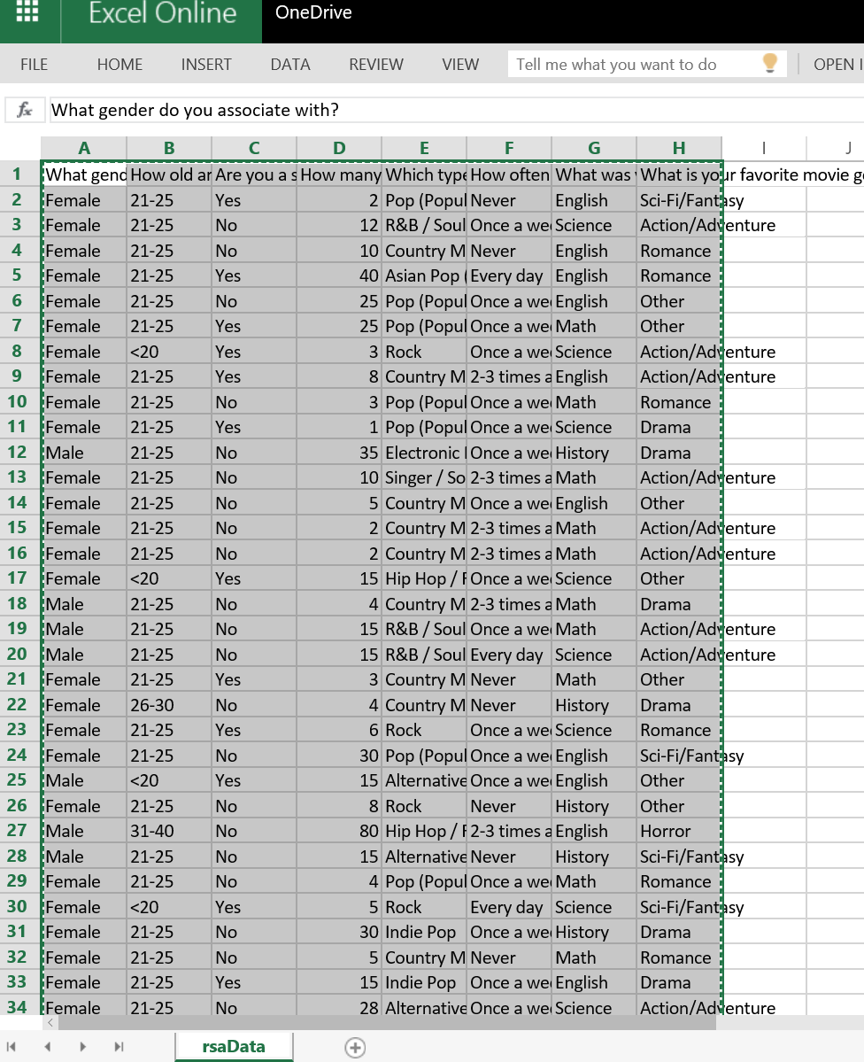

1. Go to [**http://app.raw.densitydesign.org/**](http://app.raw.densitydesign.org/)**.**
2. 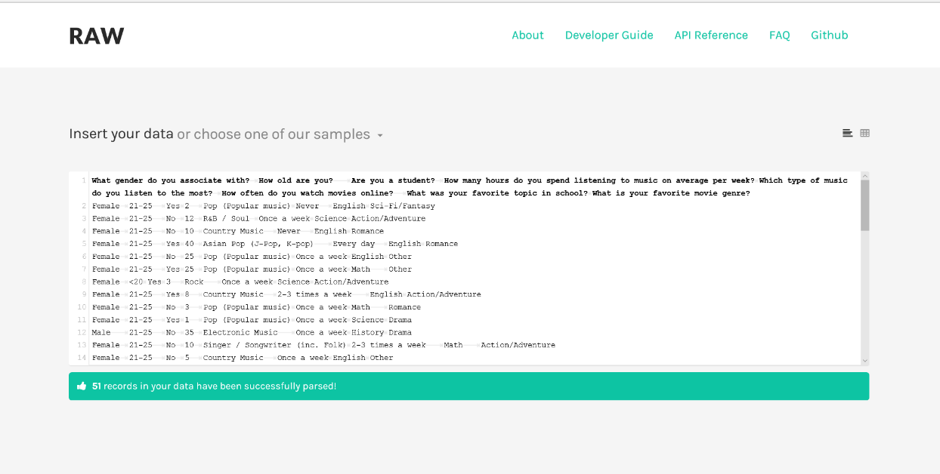In the white box, press “**Ctrl” and “V” at the same time** to paste your data in. It should look like the picture below!

### **Play around with the different types of charts that you can make. You can drag the different questions to different sections.**

1. After you find one that you like. Right click on the image and press **“Copy Picture”.**
2. Go back to the page with the PowerPoint.
3. 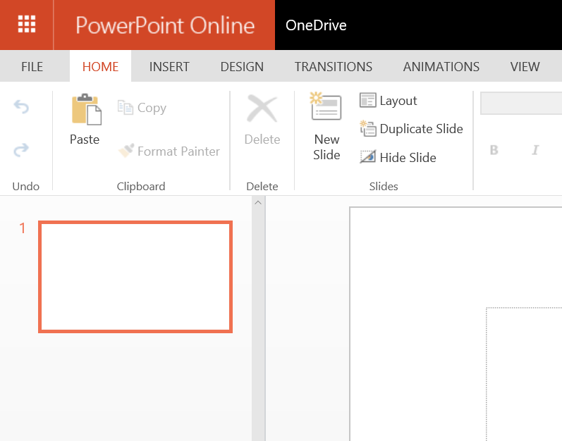Paste the image onto the slide.



1. Create 3 total visualizations that you find interesting!

## **STOP! Call Mr. Baxter or Ms. Shapiro over to check your work. Have them sign off that you made 3 visualizations and put them in PowerPoint on this sheet.**

